STATISTICS LAB—2

REG NO: 19BCS0012

NAME: NITHISH.G

DATE: 11.12.2019

VARIABLE VIEW:

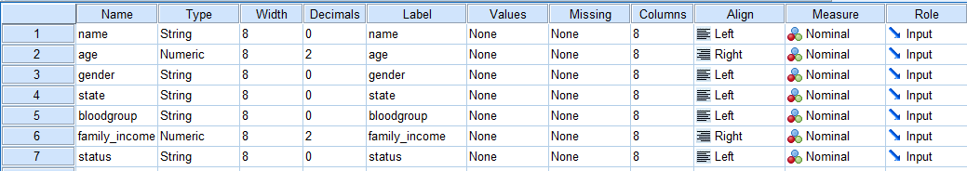

DATA VIEW:

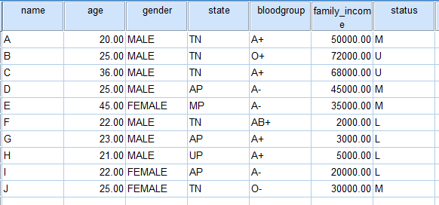

**Frequencies**

|  |  |  |  |
| --- | --- | --- | --- |
| **Statistics** | | | |
|  | | age | family_income |
| N | Valid | 10 | 10 |
| Missing | 1 | 1 |
| Mean | | 26.4000 | 33000.0000 |
| Median | | 24.0000 | 32500.0000 |
| Mode | | 25.00 | 2000.00a |
| Range | | 25.00 | 70000.00 |
| Minimum | | 20.00 | 2000.00 |
| Maximum | | 45.00 | 72000.00 |
| Sum | | 264.00 | 330000.00 |
| Percentiles | 25 | 21.7500 | 4500.0000 |
| 50 | 24.0000 | 32500.0000 |
| 75 | 27.7500 | 54500.0000 |
| a. Multiple modes exist. The smallest value is shown | | | |

**Frequency Table**

|  |  |  |  |  |  |
| --- | --- | --- | --- | --- | --- |
| **age** | | | | | |
|  | | Frequency | Percent | Valid Percent | Cumulative Percent |
| Valid | 20.00 | 1 | 9.1 | 10.0 | 10.0 |
| 21.00 | 1 | 9.1 | 10.0 | 20.0 |
| 22.00 | 2 | 18.2 | 20.0 | 40.0 |
| 23.00 | 1 | 9.1 | 10.0 | 50.0 |
| 25.00 | 3 | 27.3 | 30.0 | 80.0 |
| 36.00 | 1 | 9.1 | 10.0 | 90.0 |
| 45.00 | 1 | 9.1 | 10.0 | 100.0 |
| Total | 10 | 90.9 | 100.0 |  |
| Missing | System | 1 | 9.1 |  |  |
| Total | | 11 | 100.0 |  |  |

FREQUENCIES VARIABLES=gender state

/BARCHART FREQ

/ORDER=ANALYSIS.

**Frequencies**

|  |  |  |  |
| --- | --- | --- | --- |
| **Statistics** | | | |
|  | | gender | state |
| N | Valid | 11 | 11 |
| Missing | 0 | 0 |

**Frequency Table**

|  |  |  |  |  |  |
| --- | --- | --- | --- | --- | --- |
| **gender** | | | | | |
|  | | Frequency | Percent | Valid Percent | Cumulative Percent |
| Valid |  | 1 | 9.1 | 9.1 | 9.1 |
| FEMALE | 3 | 27.3 | 27.3 | 36.4 |
| MALE | 7 | 63.6 | 63.6 | 100.0 |
| Total | 11 | 100.0 | 100.0 |  |

|  |  |  |  |  |  |
| --- | --- | --- | --- | --- | --- |
| **state** | | | | | |
|  | | Frequency | Percent | Valid Percent | Cumulative Percent |
| Valid |  | 1 | 9.1 | 9.1 | 9.1 |
| AP | 3 | 27.3 | 27.3 | 36.4 |
| MP | 1 | 9.1 | 9.1 | 45.5 |
| TN | 5 | 45.5 | 45.5 | 90.9 |
| UP | 1 | 9.1 | 9.1 | 100.0 |
| Total | 11 | 100.0 | 100.0 |  |

**Frequencies**

|  |  |  |  |
| --- | --- | --- | --- |
| **Statistics** | | | |
|  | | gender | state |
| N | Valid | 11 | 11 |
| Missing | 0 | 0 |

**Frequency Table**

|  |  |  |  |  |  |
| --- | --- | --- | --- | --- | --- |
| **gender** | | | | | |
|  | | Frequency | Percent | Valid Percent | Cumulative Percent |
| Valid |  | 1 | 9.1 | 9.1 | 9.1 |
| FEMALE | 3 | 27.3 | 27.3 | 36.4 |
| MALE | 7 | 63.6 | 63.6 | 100.0 |
| Total | 11 | 100.0 | 100.0 |  |

|  |  |  |  |  |  |
| --- | --- | --- | --- | --- | --- |
| **state** | | | | | |
|  | | Frequency | Percent | Valid Percent | Cumulative Percent |
| Valid |  | 1 | 9.1 | 9.1 | 9.1 |
| AP | 3 | 27.3 | 27.3 | 36.4 |
| MP | 1 | 9.1 | 9.1 | 45.5 |
| TN | 5 | 45.5 | 45.5 | 90.9 |
| UP | 1 | 9.1 | 9.1 | 100.0 |
| Total | 11 | 100.0 | 100.0 |  |

**Pie Chart**

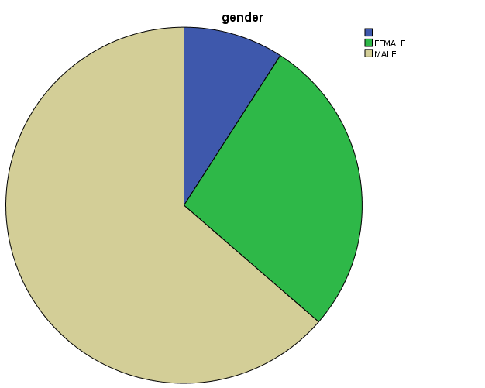

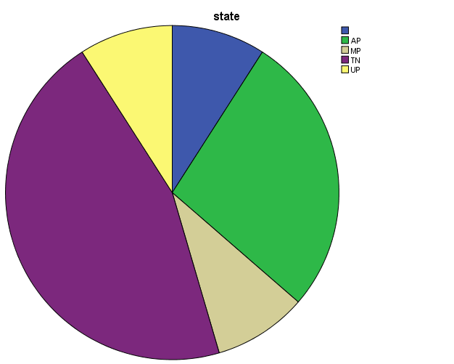

SAVE OUTFILE='C:\Users\Administrator\Desktop\19BCS0012LAB3.sav'

/COMPRESSED.

GET

FILE='C:\Users\Administrator\Desktop\19BCS0012LAB3.sav'.

Warning # 67. Command name: GET FILE

The document is already in use by another user or process. If you make

changes to the document they may overwrite changes made by others or your

changes may be overwritten by others.

File opened C:\Users\Administrator\Desktop\19BCS0012LAB3.sav

DATASET NAME DataSet1 WINDOW=FRONT.